**Task 3: Database Migration Report**

**1. Objective:**  
To migrate the EmployeeDB database from MySQL to PostgreSQL, including schema, data, and verifying query compatibility.

**2. Source and Target:**

* **Source DBMS**: MySQL
* **Target DBMS**: PostgreSQL
* **Database Name**: EmployeeDB (MySQL) → employeedb_pg (PostgreSQL)

**3. Migration Steps:**

**3.1 Exported MySQL Database**

Used **MySQL Workbench** → *Data Export* → Selected EmployeeDB → Exported structure and data to .sql file (Dump20250715.sql).

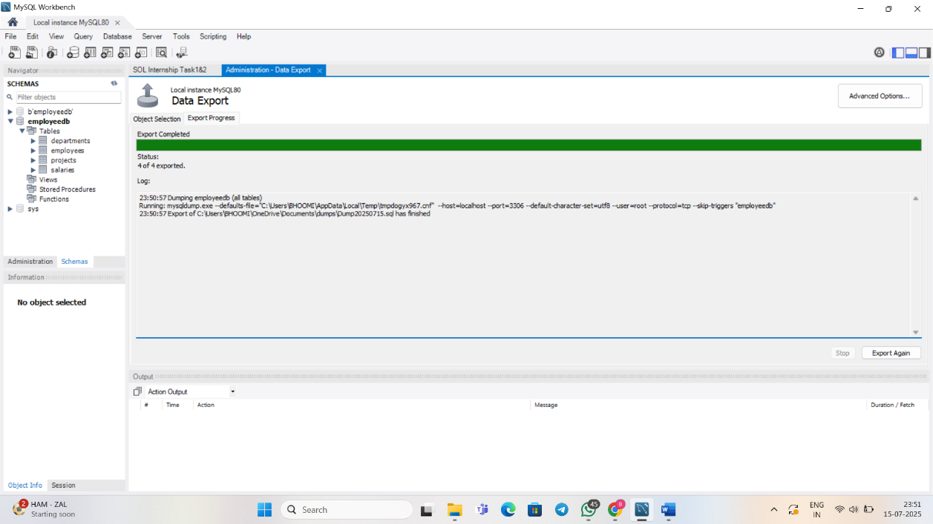

**3.2 Converted Script for PostgreSQL:**

Modified the MySQL script to make it compatible with PostgreSQL:

* Removed USE command.
* Replaced MySQL-specific data types and JOIN syntax.
* Created schema employeedb.
* Updated foreign key references as per PostgreSQL standards.

**3.3 Imported into PostgreSQL:**

Opened **pgAdmin**, created schema, and executed the modified script to recreate all tables and populate them with data.

**3.4 Verified Migration:**

Executed all major queries (JOINs, window functions, CTEs, subqueries) to ensure PostgreSQL results matched those from MySQL.

**4. Query Validation:**

Executed all relevant queries in PostgreSQL to ensure functionality:

* **Join Queries**:  
  INNER JOIN, LEFT JOIN, RIGHT JOIN, FULL OUTER JOIN, Multi-table JOINs.
* **Window Functions**:  
  ROW_NUMBER, RANK, DENSE_RANK, NTILE, LAG, LEAD, CUME_DIST, PERCENT_RANK, FIRST_VALUE, LAST_VALUE, AVG, SUM, COUNT, MIN, MAX (with and without PARTITION BY).
* **Common Table Expressions (CTEs)**:  
  High earners, department-wise total salary, and latest hire.
* **Subqueries**:  
  Employees with salary greater than Raj, departments with average salary above 60000, employee with highest bonus, and more.

All outputs were saved as CSVs.

**5. Output Files:**

* MySQL dump file (Dump20250715.sql).
* Modified PostgreSQL script.
* Output CSVs (results of queries executed in PostgreSQL).
* Original MySQL .sql script.

**6. Conclusion:**

The migration from MySQL to PostgreSQL was completed successfully. Schema, data, and queries were accurately transferred. The PostgreSQL version is fully functional and reflects the original MySQL structure and logic.